DESIGN PATTERNS
Exercise 1: Implementing the Singleton Pattern
Scenario:
You need to ensure that a logging utility class in your application has only one instance throughout the application lifecycle to ensure consistent logging.
CODE:

class Logger {
private static Logger instance;
private Logger() {}
public static Logger getInstance() {
if (instance == null) {
instance = new Logger();
}
return instance;
}
public void log(String message) {
System.out.println("[LOG]: " + message);
}
}
public class Main {
public static void main(String[] args) {
Logger logger1 = Logger.getInstance();
Logger logger2 = Logger.getInstance();

logger1.log("This is the first log message.");
logger2.log("This is the second log message.");

System.out.println("\n--- Verification Results ---");
if (logger1 == logger2) {
System.out.println("SUCCESS: Both variables point to the same instance!");
} else {
System.out.println("FAILURE: Different instances exist.");
}
}
}
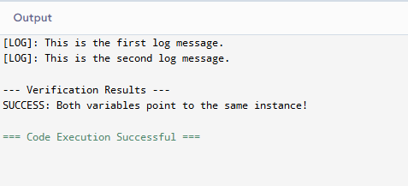

Exercise 2: Implementing the Factory Method Pattern
Scenario:
You are developing a document management system that needs to create different types of documents (e.g., Word, PDF, Excel). Use the Factory Method Pattern to achieve this.
CODE:
interface Document {
void open();
void close();
}

class WordDocument implements Document {
public void open() { System.out.println("Opening Word Document (.docx)..."); }
public void close() { System.out.println("Closing Word Document."); }
}

class PdfDocument implements Document {
public void open() { System.out.println("Opening PDF Document (.pdf)..."); }
public void close() { System.out.println("Closing PDF Document."); }
}

class ExcelDocument implements Document {
public void open() { System.out.println("Opening Excel Spreadsheet (.xlsx)..."); }
public void close() { System.out.println("Closing Excel Spreadsheet."); }
}
abstract class DocumentFactory {
public abstract Document createDocument();
}

class WordDocumentFactory extends DocumentFactory {
public Document createDocument() { return new WordDocument(); }
}

class PdfDocumentFactory extends DocumentFactory {
public Document createDocument() { return new PdfDocument(); }
}

class ExcelDocumentFactory extends DocumentFactory {
public Document createDocument() { return new ExcelDocument(); }
}

public class Main {
public static void main(String[] args) {
System.out.println("--- Document Management System ---\n");

DocumentFactory wordFactory = new WordDocumentFactory();
Document wordDoc = wordFactory.createDocument();
wordDoc.open();
wordDoc.close();

System.out.println();

DocumentFactory pdfFactory = new PdfDocumentFactory();
Document pdfDoc = pdfFactory.createDocument();
pdfDoc.open();
pdfDoc.close();

System.out.println();

DocumentFactory excelFactory = new ExcelDocumentFactory();
Document excelDoc = excelFactory.createDocument();
excelDoc.open();
excelDoc.close();
}
}
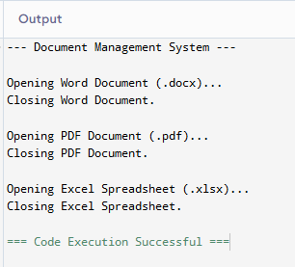

Exercise 3: Implementing the Builder Pattern
Scenario:
You are developing a system to create complex objects such as a Computer with multiple optional parts. Use the Builder Pattern to manage the construction process.
CODE:
class Computer {
private final String CPU;
private final String RAM;
private final String storage;
private final String graphicsCard;
private final boolean isBluetoothEnabled;

private Computer(Builder builder) {
this.CPU = builder.CPU;
this.RAM = builder.RAM;
this.storage = builder.storage;
this.graphicsCard = builder.graphicsCard;
this.isBluetoothEnabled = builder.isBluetoothEnabled;
}

@Override
public String toString() {
return "Computer Spec -> CPU: " + CPU + " | RAM: " + RAM +
" | Storage: " + (storage != null ? storage : "None") +
" | GPU: " + (graphicsCard != null ? graphicsCard : "Integrated") +
" | Bluetooth: " + isBluetoothEnabled;
}

public static class Builder {
private final String CPU;
private final String RAM;
private String storage;
private String graphicsCard;
private boolean isBluetoothEnabled;

public Builder(String CPU, String RAM) {
this.CPU = CPU;
this.RAM = RAM;
}

public Builder setStorage(String storage) {
this.storage = storage;
return this;
}

public Builder setGraphicsCard(String graphicsCard) {
this.graphicsCard = graphicsCard;
return this;
}

public Builder setBluetoothEnabled(boolean isBluetoothEnabled) {
this.isBluetoothEnabled = isBluetoothEnabled;
return this;
}

public Computer build() {
return new Computer(this);
}
}
}

public class Main {
public static void main(String[] args) {
Computer standard = new Computer.Builder("Intel i5", "16GB").build();
Computer premium = new Computer.Builder("Intel i9", "64GB")
.setStorage("1TB SSD")
.setGraphicsCard("RTX 4070")
.setBluetoothEnabled(true)
.build();

System.out.println(standard);
System.out.println(premium);
}
}
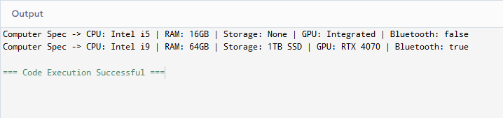

Exercise 4: Implementing the Adapter Pattern
Scenario:
You are developing a payment processing system that needs to integrate with multiple third-party payment gateways with different interfaces. Use the Adapter Pattern to achieve this.
CODE:
interface PaymentProcessor {
void processPayment(double amount);
}

class PayPalGateway {
public void sendPayment(double totalUSD) {
System.out.println("PayPal processed: $" + totalUSD);
}
}

class StripeGateway {
public void chargeCustomer(int amountInCents) {
System.out.println("Stripe processed: " + amountInCents + " cents");
}
}
class PayPalAdapter implements PaymentProcessor {
private PayPalGateway gateway;
public PayPalAdapter(PayPalGateway gateway) { this.gateway = gateway; }
public void processPayment(double amount) { gateway.sendPayment(amount); }
}

class StripeAdapter implements PaymentProcessor {
private StripeGateway gateway;
public StripeAdapter(StripeGateway gateway) { this.gateway = gateway; }
public void processPayment(double amount) { gateway.chargeCustomer((int)(amount * 100)); }
}

public class Main {
public static void main(String[] args) {
PaymentProcessor p1 = new PayPalAdapter(new PayPalGateway());
PaymentProcessor p2 = new StripeAdapter(new StripeGateway());

p1.processPayment(19.50);
p2.processPayment(19.50);
}
}
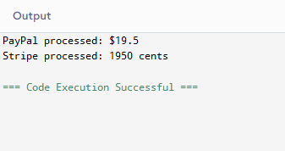

Exercise 5: Implementing the Decorator Pattern
Scenario:
You are developing a notification system where notifications can be sent via multiple channels (e.g., Email, SMS). Use the Decorator Pattern to add functionalities dynamically.
CODE:
interface Notifier {
void send(String message);
}

class EmailNotifier implements Notifier {
public void send(String message) {
System.out.println("Email Out: " + message);
}
}

abstract class NotifierDecorator implements Notifier {
protected Notifier wrapper;
public NotifierDecorator(Notifier notifier) { this.wrapper = notifier; }
public void send(String message) { wrapper.send(message); }
}

class SMSNotifierDecorator extends NotifierDecorator {
public SMSNotifierDecorator(Notifier notifier) { super(notifier); }
public void send(String message) {
super.send(message);
System.out.println("SMS Out: " + message);
}
}

class SlackNotifierDecorator extends NotifierDecorator {
public SlackNotifierDecorator(Notifier notifier) { super(notifier); }
public void send(String message) {
super.send(message);
System.out.println("Slack Out: " + message);
}
}

public class Main {
public static void main(String[] args) {
System.out.println("Deploying Multi-Channel Notification Stack:");
Notifier systemAlert = new SlackNotifierDecorator(new SMSNotifierDecorator(new EmailNotifier()));
systemAlert.send("System Update Successful.");
}
}

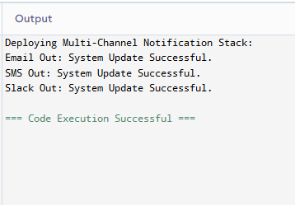

Exercise 6: Implementing the Proxy Pattern
Scenario:
You are developing an image viewer application that loads images from a remote server. Use the Proxy Pattern to add lazy initialization and caching.
CODE:
interface Image {
void display();
}

class RealImage implements Image {
private String fileName;

public RealImage(String fileName) {
this.fileName = fileName;
loadFromRemoteServer();
}

private void loadFromRemoteServer() {
System.out.println("-> [Network Loading]: " + fileName);
}

public void display() {
System.out.println("-> [Rendering Graphic]: " + fileName);
}
}

class ProxyImage implements Image {
private String fileName;
private RealImage cacheInstance;

public ProxyImage(String fileName) {
this.fileName = fileName;
}

public void display() {
if (cacheInstance == null) {
cacheInstance = new RealImage(fileName);
} else {
System.out.println("-> [Cache Hit]: Serving matching asset from cache.");
}
cacheInstance.display();
}
}

public class Main {
public static void main(String[] args) {
Image img = new ProxyImage("dashboard_analytics.png");

System.out.println("--- Action 1 ---");
img.display();

System.out.println("\n--- Action 2 ---");
img.display();
}
}

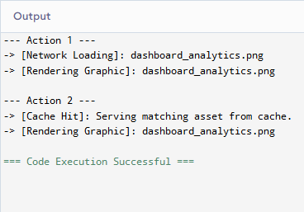

Exercise 7: Implementing the Observer Pattern
Scenario:
You are developing a stock market monitoring application where multiple clients need to be notified whenever stock prices change. Use the Observer Pattern to achieve this.
CODE:
import java.util.ArrayList;
import java.util.List;

interface Observer { void update(String stock, double price); }
interface Stock { void add(Observer o); void remove(Observer o); void notifyAllObservers(); }

class StockMarket implements Stock {
private List<Observer> list = new ArrayList<>();
private String sym; private double prc;

public void add(Observer o) { list.add(o); }
public void remove(Observer o) { list.remove(o); }
public void notifyAllObservers() { for(Observer o : list) o.update(sym, prc); }

public void updatePrice(String sym, double prc) {
this.sym = sym; this.prc = prc;
notifyAllObservers();
}
}

class MobileApp implements Observer {
public void update(String s, double p) { System.out.println("Mobile View -> " + s + ": $" + p); }
}
class WebApp implements Observer {
public void update(String s, double p) { System.out.println("Web Chart -> " + s + ": $" + p); }
}

public class Main {
public static void main(String[] args) {
StockMarket market = new StockMarket();
Observer m = new MobileApp();
Observer w = new WebApp();

market.add(m); market.add(w);
System.out.println("--- Update 1 ---");
market.updatePrice("GOOG", 142.50);
}
}

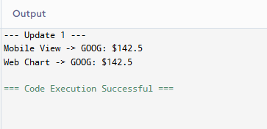

Exercise 8: Implementing the Strategy Pattern
Scenario:
You are developing a payment system where different payment methods (e.g., Credit Card, PayPal) can be selected at runtime. Use the Strategy Pattern to achieve this.
CODE:
interface PaymentStrategy {
void pay(double amount);
}

class CreditCardPayment implements PaymentStrategy {
private String name;
public CreditCardPayment(String name) { this.name = name; }
public void pay(double amount) {
System.out.println("Paid $" + amount + " with Credit Card for owner " + name);
}
}

class PayPalPayment implements PaymentStrategy {
private String email;
public PayPalPayment(String email) { this.email = email; }
public void pay(double amount) {
System.out.println("Paid $" + amount + " with PayPal account " + email);
}
}

class PaymentContext {
private PaymentStrategy strategy;
public void setStrategy(PaymentStrategy strategy) { this.strategy = strategy; }
public void executePayment(double amount) {
strategy.pay(amount);
}
}

public class Main {
public static void main(String[] args) {
PaymentContext context = new PaymentContext();

System.out.println("--- Action 1 ---");
context.setStrategy(new CreditCardPayment("Alice"));
context.executePayment(25.00);

System.out.println("\n--- Action 2 ---");
context.setStrategy(new PayPalPayment("alice@example.com"));
context.executePayment(42.50);
}
}

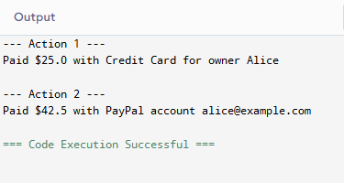

Exercise 9: Implementing the Command Pattern
Scenario: You are developing a home automation system where commands can be issued to turn devices on or off. Use the Command Pattern to achieve this.
CODE:

class Light {
public void turnOn() { System.out.println("Light state: ON"); }
public void turnOff() { System.out.println("Light state: OFF"); }
}

interface Command { void execute(); }

class LightOnCommand implements Command {
private Light light;
public LightOnCommand(Light light) { this.light = light; }
public void execute() { light.turnOn(); }
}

class LightOffCommand implements Command {
private Light light;
public LightOffCommand(Light light) { this.light = light; }
public void execute() { light.turnOff(); }
}

class RemoteControl {
private Command cmd;
public void setCommand(Command cmd) { this.cmd = cmd; }
public void pressButton() { cmd.execute(); }
}

public class Main {
public static void main(String[] args) {
Light homeLight = new Light();
RemoteControl remote = new RemoteControl();

remote.setCommand(new LightOnCommand(homeLight));
remote.pressButton();

remote.setCommand(new LightOffCommand(homeLight));
remote.pressButton();
}
}

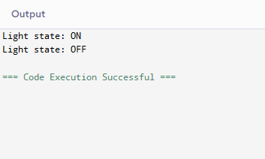

Exercise 10: Implementing the MVC Pattern
Scenario:
You are developing a simple web application for managing student records using the MVC pattern.
CODE:

class Student {
private String name, id, grade;
public String getName() { return name; }
public void setName(String name) { this.name = name; }
public String getId() { return id; }
public void setId(String id) { this.id = id; }
public String getGrade() { return grade; }
public void setGrade(String grade) { this.grade = grade; }
}

class StudentView {
public void displayStudentDetails(String n, String i, String g) {
System.out.println("Profile -> ID: " + i + " | Name: " + n + " | Grade: " + g);
}
}

class StudentController {
private Student model;
private StudentView view;
public StudentController(Student m, StudentView v) { this.model = m; this.view = v; }
public void setStudentName(String name) { model.setName(name); }
public void setStudentGrade(String grade) { model.setGrade(grade); }
public void updateView() { view.displayStudentDetails(model.getName(), model.getId(), model.getGrade()); }
}

public class Main {
public static void main(String[] args) {
Student s = new Student();
s.setName("Alice"); s.setId("101"); s.setGrade("B");

StudentController ctrl = new StudentController(s, new StudentView());
ctrl.updateView();

ctrl.setStudentName("Bob");
ctrl.setStudentGrade("A");
ctrl.updateView();
}
}

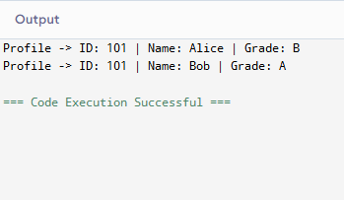

Exercise 11: Implementing Dependency Injection
Scenario:
You are developing a customer management application where the service class depends on a repository class. Use Dependency Injection to manage these dependencies.
CODE:
interface CustomerRepository {
String findCustomerById(int id);
}

class CustomerRepositoryImpl implements CustomerRepository {
public String findCustomerById(int id) {
return (id == 7) ? "John Doe" : "Record Not Found";
}
}

class CustomerService {
private final CustomerRepository repository;

public CustomerService(CustomerRepository repository) {
this.repository = repository;
}

public void getCustomerName(int id) {
System.out.println("Resolved Name: " + repository.findCustomerById(id));
}
}

public class Main {
public static void main(String[] args) {

CustomerRepository repo = new CustomerRepositoryImpl();
CustomerService service = new CustomerService(repo);

service.getCustomerName(7);
service.getCustomerName(12);
}
}
